Lab 2 - ESP32 Bluetooth

Adapted tutorial from randomnerdtutorials.com https://randomnerdtutorials.com/esp32-bluetooth-classic-arduino-ide/

## Learning Outcomes:

* Connect to esp32 bluetooth module
* Blink led with commands via bluetooth

## Background:

The esp32 comes with an onboard bluetooth module. This allows us to connect directly to it without any other hardware. We could do this lab with an Arduino board but it requires us to attach a bluetooth module.

## Step 1 Download Serial Bluetooth Terminal:

For this lab you will need an Android phone. Go to the Play Store and download the Serial Bluetooth Terminal app. It looks like this:

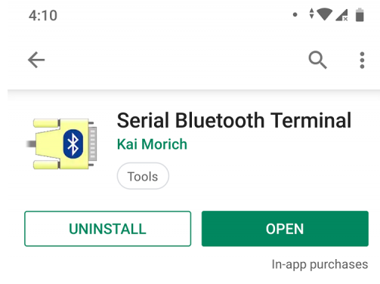

## Step 2 Download and Upload Code:

Copy paste the code provided with this lab into the Arduino IDE. Then flash the code to your board. After the code uploads, open the Serial Monitor at a baud rate of 115200. Press the ESP32 Enable Button. It’s the one that has RST by it, not BOOT.

After a few seconds, you should get a message saying: “The device started now you can pair it with bluetooth!”.

## Step 3 Connect:

Enable Bluetooth on your phone. Open the Serial Bluetooth App, To connect with a new device click the Devices tab. Select Pair new device. You’ll then see a list of available devices. Select the ESP32test device. Go back to the terminal and you should see output like this:

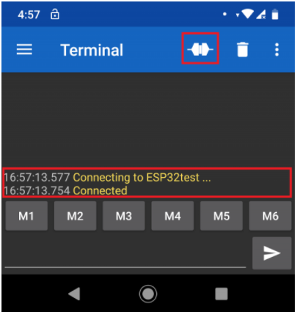

Try typing something in the terminal on your phone. You should also see the message on the serial monitor. And vice versa.

## Step 4 Turn on Led via BT:

Next we will be lighting an LED via BT. First create the circuit in the picture below, minus the thermometer connected to GPIO 32.

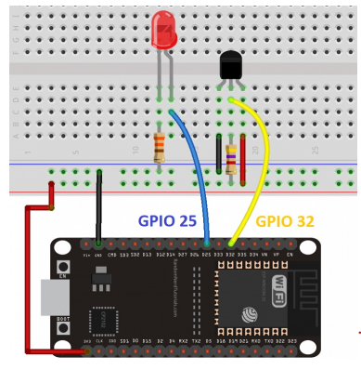

Copy and paste the code provided into the IDE. Upload it to the ESP32. After the code flashes you should be able to turn the LED on by typing “led_on” and “led_off” in the terminal.

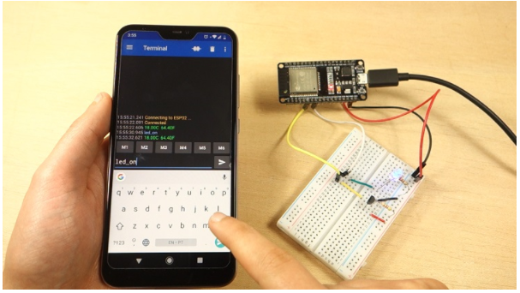

We can also assign a button to each message. Go to the menu and select Edit Macros. Create a name for each and assign “led_on”, and “led_off” for the values. Make it text edit mode. You now can control the led by pressing your button.

You can also edit the button’s by long pressing them.